 | INTERNATIONAL TELECOMMUNICATION UNION  TELECOMMUNICATION  STANDARDIZATION SECTOR  STUDY PERIOD 2022-2024 |  | SG12-TD460R1
 |  |  | STUDY GROUP 12
 |  |  | Original: English
Question(s): |  | 10/12 |  | Mexico City, 19-28 September 2023
TD
Source: |  | Editors P.UXV
Title: |  | Base text P.UXV: User experience of multimedia in videotelephony and videoconferencing services
Contact: |  | Mengying Liu  China Mobile Communications Corporation  China |  |  | Tel: +86 13810334606  E-mail: liumengying@chinamobile.com
Contact: |  | Vincent Barriac  Orange  France |  |  | Tel: +33 296071810  E-mail: vincent.barriac@orange.com

Abstract: | This TD contains the base text of work item ITU-T P.UXV: User experience of multimedia in videotelephony and videoconferencing services.

Annex A
Draft new Recommendation P.UXV

User experience of multimedia in videotelephony and videoconferencing services
Summary:
This draft Recommendation concerns the user experience on common multimedia components and extended functions in videotelephony and videoconferencing systems. Common multimedia components include mainstream audio and video for real-time communication, substream multimedia (mainly video) that assist the communication. Extended functions like screen sharing, background replacement, normally introduce substream multimedia or perform additional processing on mainstream multimedia.
This draft Recommendation gives an overview of key influencing factors of common multimedia components and extended functions. It provides guidance on recommendations concerning the user experience of real-time communication, and specifics the key influencing factors and subjective assessment of substream multimedia and extended multimedia functions.
Keywords:
Videotelephony, videoconferencing, user experience, subjective assessment, multimedia functions.

Scope
This draft Recommendation concerns the user experience related to multimedia in videotelephony and videoconferencing services, by analyzing multimedia components and multimedia functions in videotelephony and video-conferencing services.
The scope of this draft Recommendation includes:
- Key influencing factors of various multimedia elements and multimedia functions that affect user experience in videotelephony services.
- Analysis of mainstream multimedia and related existing recommendations that concerns the user experience of real-time communication to provide guidance.
- Subjective assessment for user experience of substream multimedia (e.g. screen sharing) and extended multimedia functions (e.g. background blurring, background replacement, virtual avatar)

References
The following ITU-T Recommendations and other references contain provisions, which, through reference in this text, constitute provisions of this Recommendation. At the time of publication, the editions indicated were valid. All Recommendations and other references are subject to revision; all users of this Recommendation are therefore encouraged to investigate the possibility of applying the most recent edition of the Recommendations and other references listed below.
[ITU-T P.805] Recommendation ITU-T P.805 (2007), Subjective evaluation of conversational quality.
[ITU-T P.920] Recommendation ITU-T P.920 (2000), Interactive test methods for audiovisual communications.
[ITU-T P.931] Recommendation ITU-T P.931 (2016), Multimedia communications delay, synchronization and frame rate measurement.
[ITU-T P.1301] Recommendation ITU-T P.1301 (2017), Subjective quality evaluation of audio and audiovisual multiparty telemeetings.
[ITU-T P.1302] Recommendation ITU-T P.1302 (2014), Subjective method for simulated conversation tests addressing speech and audio-visual call quality.
[ITU-T P.1305] Recommendation ITU-T P.1305 (2016), Effect of delays on telemeeting quality.
[ITU-T P.1320] Recommendation ITU-T P.1320 (2022), Quality of experience assessment of extended reality meetings.

Definitions

3.1 Terms defined elsewhere
3.1.1 augmented reality (AR) [ITU-T P.1320]: An environment containing both read and virtual sensory components.
3.1.2 conversational quality [ITU-T P.1301]: The perceived quality when two or more test participants have a conversation.
3.1.3 quality of experience [b-ITU-T P.10 Amd.2]: The overall acceptability of an application or service, as perceived subjectively by the end-user.
[TBD]

3.2 Terms Defined within this document
This document defines the following terms.
[TBD]

Abbreviations
This recommendation uses the following abbreviations.
ACR Absolute Category Rating
AR Augmented Reality
MOS Mean Opinion Score
QoE Quality of Experience
QoS Quality of Service

Conventions
None

Multimedia components and functions in videotelephony / videoconferencing
This chapter analyzes the multimedia functions provided by videotelephony/videoconferencing services, which mainly consist of real-time communication and extended multimedia functions.
Real-time communication function is realized based on mainstream audio captured from microphone and mainstream video captured from camera. In terms of extended multimedia functions, screen sharing introduces substream video from the screen of terminal device. The substream video is also transmitted through media channel as an independent video stream with specific video profile. Other extended multimedia functions like background blurring/replacement, AR interaction effects, perform additional processing to mainstream video captured from camera. The additional processing can be conducted at the server side or client side, and uses multimedia material from pre-set media library or user imported media resources.
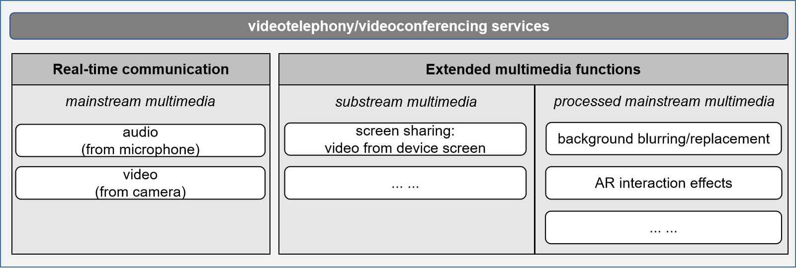
[TBD]

Factors influencing user experience of multimedia interaction in videotelephony / videoconferencing
This chapter studies the key influencing factors of multimedia components and multimedia functions that affect user experience in videotelephony services, by applying the Telemeeting Profile Template recommended in G.1092 (ex G.TeleMeTax). The numerous factors that affect user experience are generally divided into three main categories: Human Influence Factors, System Influence Factors and Content Influence Factors. Researches will be conducted by referring to G.1092 (ex G.TeleMeTax) and identify the key Quality Influence Factors for each specific multimedia function.

7.1 Real-time communication: audio call
Including but not limited to audio codec, transmission latency, stalling, blockiness, noise.
[TBD]

7.2 Real-time communication: audiovisual call
Including but not limited to media codec, transmission latency, stalling, blockiness, video loading time, synchronization between audio and video.
[TBD]

7.3 Screen sharing
Including but not limited to video codec, transmission latency, stalling, blurriness, video loading time
[TBD]

7.4 Background blurring/replacement
Including but not limited to video codec, end-to-end latency, stalling, recognition accuracy, margin smoothness
[TBD]

7.5 AR effects (virtual avatar, AR interaction effects)
Including but not limited to media codec, end-to-end latency, stalling, blockiness, recognition accuracy.
[TBD]

Existing Recommendations concerning user experience of audiovisual communications
This chapter analyzes the mainstream multimedia and related existing recommendations concerns the user experience of real-time communication to provide some suggestion if subjective assessment of real-time communication is needed. Existing recommendations such as P.1301, P.911, P.920 will be suggested in this part.
[TBD]

Subjective assessment methodologies concerning user experience of extended multimedia functions
This chapter focuses on the subjective assessment methodologies for user experience of extended multimedia functions. Both passive and active tests are taken into consideration and will be designed accordingly for each specific function.

9.1 User experience of screen sharing
[TBD]

9.2 User experience of background blurring/replacement
[TBD]

9.3 User experience of AR effects (virtual avatar, AR interaction effects)
[TBD]

Bibliography
[b-ITU-T P.10 Amd.2] Recommendation ITU-T P.10/G100 (2006) Amendment 2 (2008), New definitions for inclusion in Recommendation ITU-T P.10/G.100.

