INTERNATIONAL TELECOMMUNICATION UNION |  | STUDY GROUP 9
TELECOMMUNICATION  STANDARDIZATION SECTOR  STUDY PERIOD 2013-2016 |  | TD 642 (GEN/9)
English only
Original: English
Question(s): | 12/9 | Beijing, 10-17 June 2015
TD
Source: | Rapporteurs of Q2/9 and Q12/9
Title: | Output—Draft New Recommendation- P.3D-fatigue “Information and guidelines for assessing and minimizing visual discomfort and visual fatigue from 3D video”—clean copy, changes accepted Output—(San Jose, 27 February 2015)
Editor Note: This document represents edits recommended by the Video Quality Experts Group (VQEG) during the 27 February, 2015, Q2/9 & Q12/9 Rapporteur Group Meeting. The base text was TD 340 Rev. 1 (J.3D-fatigue). This is a clean copy with all changes accepted and formatting corrections. This document should be used as a baseline for further edits.
----------------<Recommendation No.>

Draft New Recommendation P.3D-fatigue: Information and guidelines for assessing and minimizing visual discomfort and visual fatigue from 3D video

AAP Summary
<to be added before consent>

Summary

This Recommendation addresses issues related to assessing and minimizing visual discomfort and visual fatigue from 3D video. Issues addressed include 3D video characteristics that cause visual discomfort; symptoms of visual fatigue; relationships among the camera positions, the captured content, and the viewer’s perception; footage guidelines; viewer guidelines; information on the 3D; and viewing environment considerations.

Keywords
This clause is intentionally left blank.
Introduction
3DTV systems are based on binocular disparity. Compared to the real world scenario, the reproduction of depth in 3DTV systems is limited to by the camera position, number of cameras, source content, and the technical limitations of the display technique. These include to resolution, frame rate, and view separation conditions. Current display technologies may also induce a conflict between accommodation (eyes focusing on the screen) and the convergence (eyes converging to a point in front of or behind the screen). These limitations can cause visual discomfort and visual fatigue.

1 Scope
This Recommendation includes information and guidelines for assessing and avoiding visual discomfort and visual fatigue from 3D video. It describes potential causes of visual discomfort and symptoms of 3D visual fatigue, including problems caused by watching stereoscopic and autostereoscopic television. This information is primarily intended to be used for the design and conduct of subjective assessment of the video or audiovisual quality of 3D video. It is appropriate for all 3D viewing experiences.
1.1 Limitations
This Recommendation includes guidance on recognizing visual fatigue symptoms and identifying 3D programming clip characteristics that may cause visual fatigue.
This Recommendation excludes objective assessment methods of 3D visual fatigue, because these are not computational algorithms but rather correspond to a medical diagnostic process performed by medical doctors.

2 References
None.

3 Definitions

3.2 Terms defined elsewhere
None.

3.2 Terms defined in this Recommendation
This Recommendation defines the following terms:
3.2.1 Accomodation-vergence conflict: Accomodation (eyes focussing on an object) and convergence (eyes pointing toward the object) are normally linked. Accomodation-vergence conflict is a conflict between accommodation (eyes focusing on the screen) and the convergence (eyes converging to a point in front of or behind the screen). Current 3D display technologies may induce accommodation-vergence conflict.
3.2.2 Binocular disparity: The difference between corresponding points seen by the left and right eyes. This can be the strongest depth cue for close objects.
3.2.3 Binocular depth cues: Binocular depth cues stem from binocular disparity and the state of the oculomotor system.
3.2.4 Cardboard effect: The cardboard effect occurs when the imaging and display conditions reduces the reproduction magnification ratio of depth directions and distorts the perception of objects with visually imperceptible thickness. The 3-D positions of stereoscopic objects are perceived stereoscopically but they appear unnaturally thin.
3.2.5 Depth cues: Visual indicators of the relative distances between the observer and viewed objects. There are binocular and monocular depth cues.
3.2.6 Depth distortion: Depth distortion is the discrepancy between the displayed depth reconstruction and real world. The cardboard effect is one example of a depth distortion.
3.2.7 Depth motion: Objects moving in depth (e.g., toward the viewer) .
3.2.8 Depth resolution: spatial resolution in depth direction.
3.2.9 Frame effect: 3D pictures appear highly unnatural when objects positioned in front of the screen approach the screen frame. This unnatural effect is called “the frame effect”. The effect is generally reduced with a larger screen, because observers are less conscious of the existence of the frame when the screen is larger.
3.2.10 Medical signs: Medical signs are physiological reactions that are measured and interpreted within a controlled procedure.
3.2.11 Medical symptoms: Medical symptoms are expressed by the observer and constitute an indication of his or her perceived mental or physical state.
3.2.12 Planar motion: Motion with constant depth (i.e., within a plane perpendicular to the observer).
3.2.13 Puppet theater effect: This is an example of size distortion. The reproduction magnification ratio of an object at the shooting distance (the perceived size) varies with the imaging and display conditions. The resulting distortion in size may make an object be perceived as unnaturally small.
3.2.14 Size distortion: Distortions in the 3D geometry may occur due to inconsistencies between the capturing situation (notably the camera settings) and the reproduction (notably the display settings). The puppet theater effect is an example.
3.2.15 Monocular depth cues: Monocular depth cues can be perceived from a single eye’s view. They include occlusion (objects hidden behind other objects), relative sizes of known objects, vanishing point perception, blur from the focus, motion parallax, light, shade, texture gradient, aerial perspective, height in the visual field, kinetic depth, and others.
3.2.16 Visual comfort zone: Depth interval of displayed content which does not induce visual discomfort. is defined as the depth interval which allows for 3D viewing without the introduction of visual discomfort
3.2.17 Visual discomfort: Visual discomfort is a negative sensation that is subjective reported. Visual discomfort may be triggered by the perception of 3D presentations. When present, visual discomfort is usually a transient state that disappears quickly after the person stops watching the problematic stimuli. The amount and duration of visual discomfort is highly individual. Visual discomfort may have other causes, such as visual flicker.
3.2.18 Visual fatigue: Visual fatigue is generally caused by the repetition of excessive visual effort and can build up as these efforts are repeated. It disappears after sufficient rest. Visual fatigue is a medical state that may be objectively diagnosed by the presence of objective indications (medical signs) and subjective indications (medical symptoms). Visual fatigue can only be diagnosed by a medical doctor.
3.2.19 Window violation: Window violation occurs when an object that is in front of the display overlaps the border of the screen. The 3D screen is often be perceived as a window, and in the real world objects can only be cropped when they lie behind the window. However, objects with crossed disparity are also cropped. When this occurs, the part of the object within the screen appears to be in front of the screen, while the cropping conflicts with this perception, by implying that the object should be at the depth of the screen or behind the screen.

4 Abbreviations and acronyms
This Recommendation uses the following abbreviations and acronyms:
ABV Abnormal Binocular Vision

5 Conventions
“3D” in this Recommendation refers to a technology that projects dedicated views for each eye. The ultimate goal is these views depict the same situation as would be seen in reality (e.g., horizontally shifted). The technology as a whole can include more than two views, as per a multi-view autostereoscopic display. This can be noted as S3D for stereoscopic TV, or 3DMV for multiview.

6 Technological Issues for 3D Displaying
This clause describes background information required to understand technological issues for displaying 3D content, including constraints of camera capture, transmission, display, and the human visual system.
6.1 Accomodation-vergence conflict
Accomodation (eyes focussing on an object) and convergence (eyes pointing toward the object) are normally linked. Current 3D display technologies cause a conflict because accommodation and convergence do not follow the usual pattern. With 3D displays, the eyes focus on the screen but the eyes converge to a point in front of or behind the screen. This is the accommodation-vergence conflict.
The accommodation-vergence conflict has a static component (as described above) and also has a temporal component due to a link within the vision system. The accommodation control system and vergence ocular motor system are linked. Changes in accommodation automatically induce changes in vergence, and vice versa. This is the temporal component of the accommodation-vergence conflict. This is in conflict with current 3D display technology, because the accommodation always stays on the screen while the vergence changes according to the virtual object’s position (binocular disparity).
More research is needed, because [b-Shiomi] indicates that there is no accommodation-vergence conflict.
6.2 3D geometric distortions
A disagreement between monocular and binocular depth cues may lead to visual discomfort. Disparity is the most important binocolular depth cue.
In case of multi-view transmission, including stereoscopic transmissions, the resolution of the image impacts on the precision of the horizontal disparity and thus of the depth resolution. Likewise, in Multi-View plus Depth representations, the resolution of the depth map limits the picture quality of synthesized views.
The quality of the depth rendering is affected by both recording and display condition which are closely linked.
In order to respect the 3D geometry of the scene during the reconstitution it is necessary to have an agreement between the different depths cues (monoculars and binocular) involved in the scenes. For example in case of cardboard effect, the monocular depth cues describe a continuous variation of depth but the binocular depth cues show less variation of depth than the monocular ones. These contradictions between the different depth cues are something unnatural and the scene looks layered.
To ensure respect of 3D geometry, it is then needed to consider the characteristics of the video camera and the target display at the moment of the capture to ensure no conflicts between monocular and binocular depth cues [b-Chen2] [b-Woods]. The distortion of the depth rendering can be evaluated as follow:
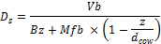

With:
- f: the focal length of the camera
- b: the inter-camera baseline (distance between focal length)
- w_ccd,h_ccd Camera sensor width and height
- d_cov the convergence distance
- (x,y,z) the position of a point in camera space (in front of the camera)
- B inter-pupil baseline: the distance between the eyes of the observers
- W_screenthe width of the display
- M the magnification factor, M=W_screen/w_ccd
These factors should be taken into-account during capture. If not, conflict between depth cues will be revealed and distortion of the 3D geometry of objects will appear.
Figure 1 and Figure 2 provides examples of different capture and display settings on with their redering on a specific display [b-Woods].

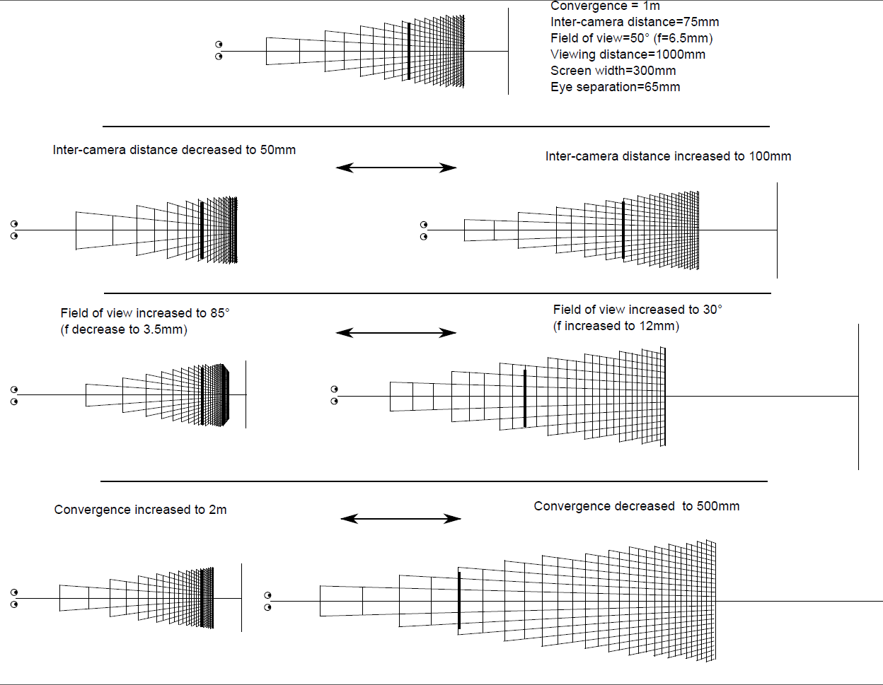
Figure 1: Examples of different capture settings and their respective effect on the depth redering on a fixed display [b-Woods]
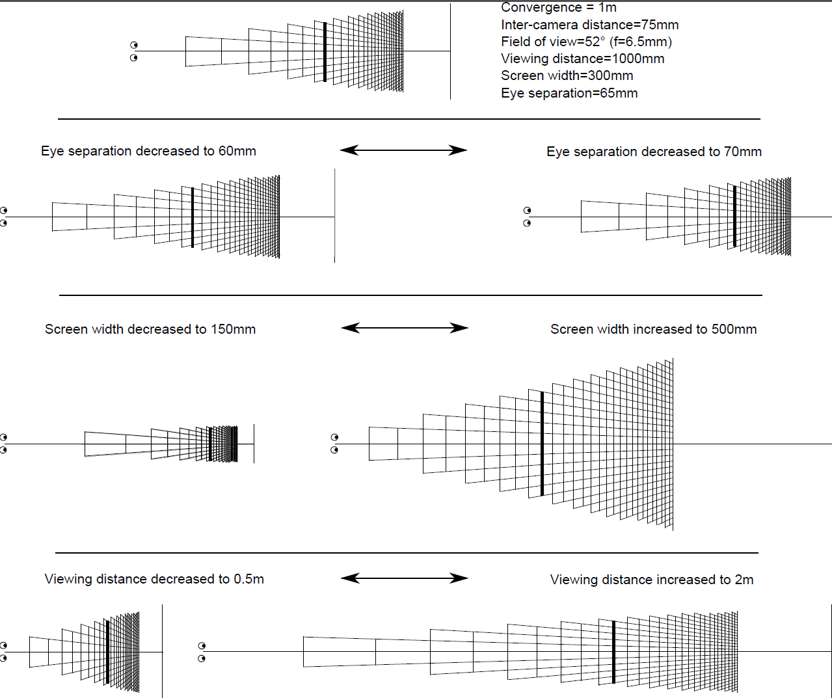
Figure 2: Examples of different redering settings and their respective effect on the depth redering of content captured with fixed settings[b-Woods]

6.3 Visual comfort zone or comfortable viewing zone

See clause 3.2 for the definition of Visual Comfort Zone. At this time, several similar but not identical parameters have been identified, notably linked to the Depth of Field (+/- 0.2 diopters), +/-1 degree, +1/-2% [b-Chen, b-Yano, b-Speranza, b-Mendiburu].The Visual Comfort Zone with these constraints depends on the viewing distance as depicted in the following diagram.

The comparison of these different comfortable viewing zones is shown in the following figure. Generally, these definitions generate similar comfort area [b-Tam]. [Editor’s Note: There should be clarification on which percent of the population is referred to (e.g., for visual comfort zone and the below figure.)]
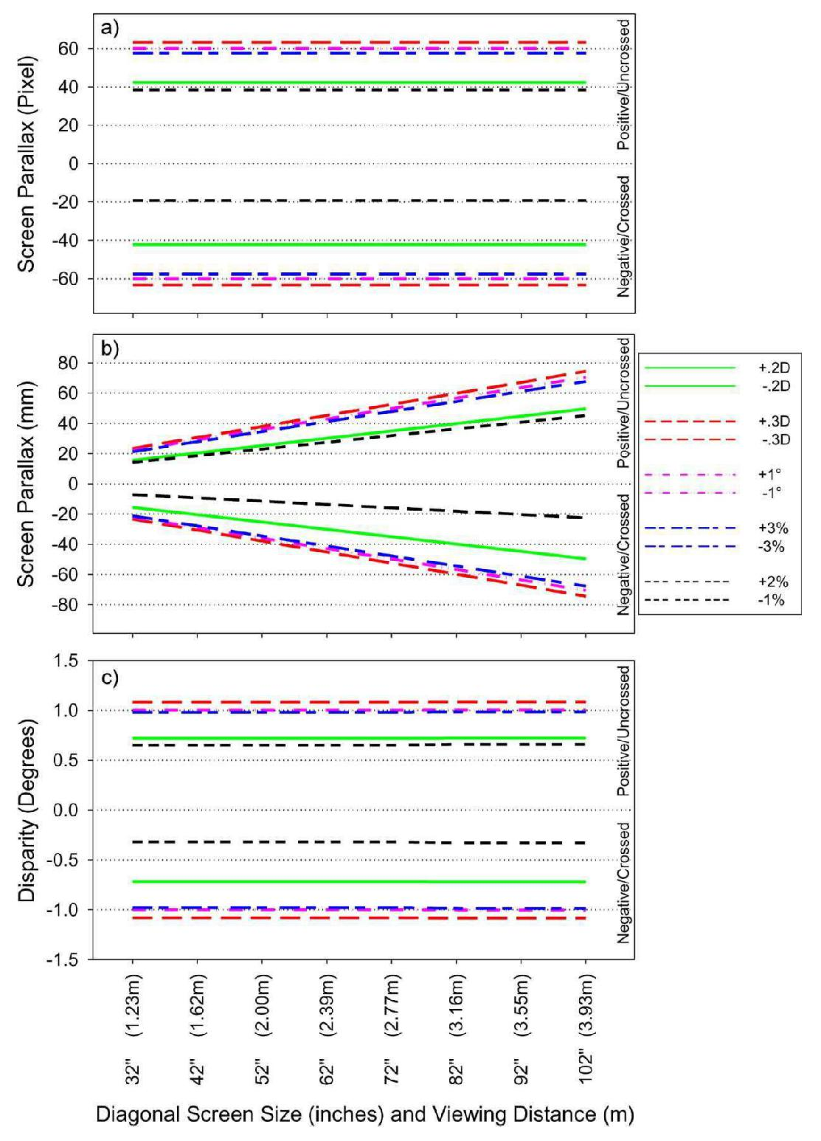
Fig X. Comparison on different definitions on comfortable viewing zone. The viewing distance is 3 times of the screen height [b-Tam]. [This title must be changed, as it is difficult to understand the figure from this text; in visual comfort zone definition (3.2), add which units the zones can be expressed in; add text above.]

7 Binocular Disparity Relationship in Capturing, Storing and Rendering
This clause explains the link between the camera positions while capturing, the resulting disparity in the captured content, and the perceived angular disparity at the viewer.
7.1 Conversion equations
The following equations are taken from [b-Chen].
Viewing distance:
d: Viewing distance
px: pixel width
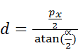

Maximum uncrossed disparities: (eyes should not diverge)
e: inter-pupillary distance
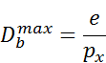
Foreground distance of comfortable viewing zone
Zf: largest distance between the farthest object in front of the display and the display
Zb: largest distance between the farthest object in the background of the scene and the screen

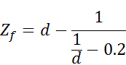
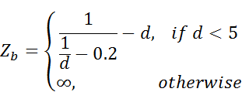

Depth rendering abilities in pixel:
Df: maximum crossed disparity in pixel
Db: maximum uncrossed disparity in pixel
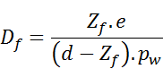
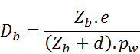
7.2 Conversion of pixel disparities to a perceptual space
7.2.1 Retinal disparities
Figure 3 represents the retinal binocular disparity, or stereopsis: the two eyes see two distinct objects and the projection of these object on the retina appear to be at different location on the retina of each eye. The differences of the position between these two projections are the retinal disparity. This information is processed by the brain to estimate of the relative position in depth between the two objects and is the most important binocular depth cue.

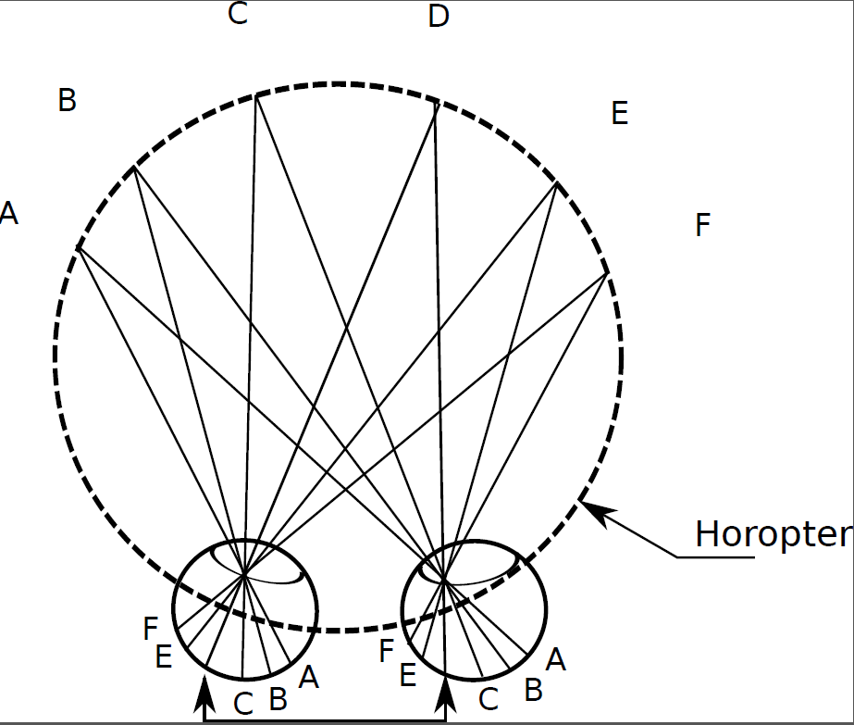
Figure 3: Horopter
To determine the retinal disparities, from disparity in pixels on the display, the position of the 3D objects taking into account the viewing conditions can be determined using the following formula [b-Chen2]:
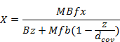
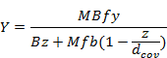
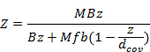

With:
- f: the focal length of the camera
- b: the inter-camera baseline (distance between focal length)
- w_ccd,h_ccd Camera sensor width and height
- d_cov the convergence distance
- (x,y,z) the position of a point in camera space (in front of the camera)
- B inter-pupil baseline: the distance between the eyes of the observers
- W_screenthe width of the display
- M the magnification factor, M=W_screen/w_ccd

Based on the position of the object in the visualization space, it is possible to determine the retinal disparities using the set of equations proposed by Cormack [b-Cormack].

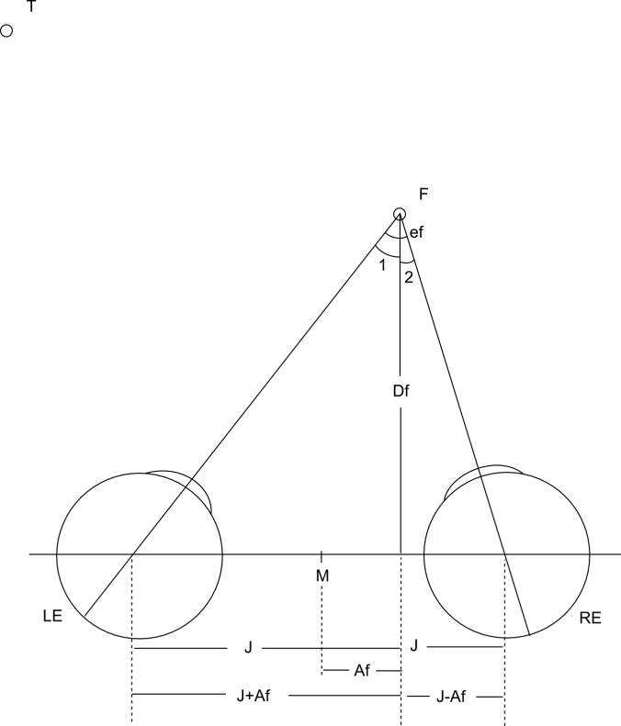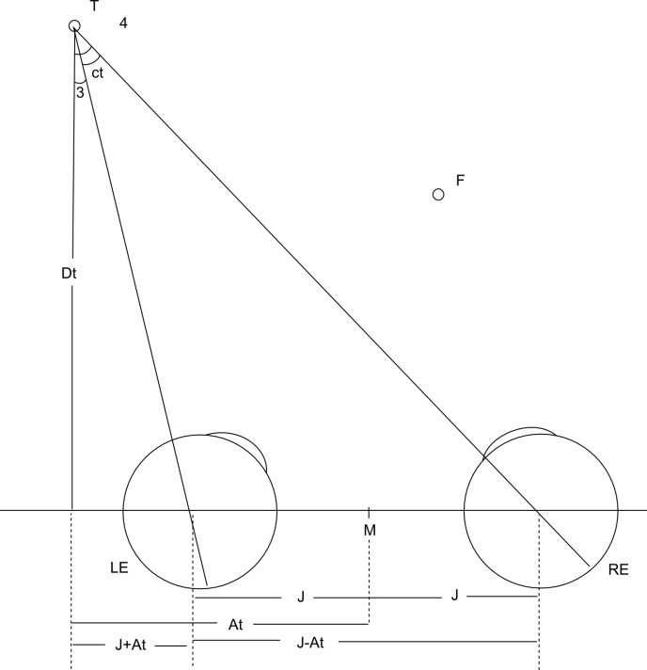

The retinal disparities are the differences between two observed points:
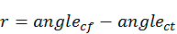
Each of these angle can be determined as follow:
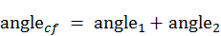
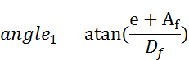
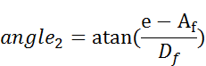

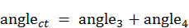
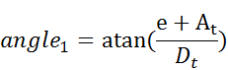
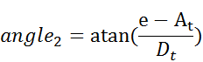

Resulting in the following equation:
In the special case of the midsaggital plane, it is possible to simplify these equations to:
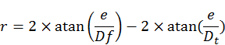
7.2.2 Parallax in degree
Parallax values can be computed to study the perceptual properties of the source content under study enabling to select 3D content while being aware of their depth characterisitcs.
Parallax values can be determined as follow [b-Lin]:
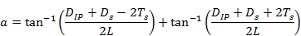
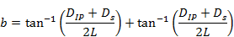
With:
- D_IP: the inter-pupillary distance in meter
- D_s: the disparity on the display in meter
- L: the viewing distance
- T_s: determine the convergence point which considering the surface of the horopter may not be constant in the plane screen [b-Schreiberetal]

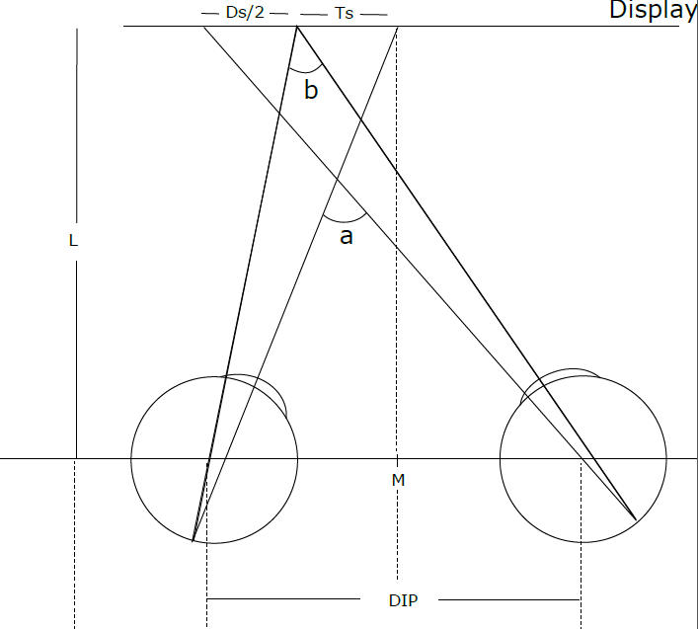

7.3 Typical constraints for displays
As expressed though the equations in section 7.1, the use of different displays having different resolution and size, in addition to different viewing condition affect the 3D rendering capabilities. The following table apply the equations from section 7.1 to typical display configuration (SD, HD, and HUD), providing information for these standard scenario of what the viewing distance should be to ensure the perception of the full resolution of the display. The viewing distance being set, this imply:
- Constrains on the contents maximum disparities to ensure a comfortable viewing experience
- A depth range where the 3D object will be perceived

 | SD
Resolution | 720x576 |  | 720x480
Display diagonal (inch) | 24 | 32 | 24 | 32
Display height (m) | 0.366 | 0.488 | 0.366 | 0.488
Pixel width (mm) | 0.635 | 0.847 | 0.762 | 1.016
Viewing distance (m) | 2.183 | 2.911 | 2.620 | 3.493
Viewing distance (times H) | 5.968 | 5.968 | 7.162 | 7.162
Maximum uncross disparity (pixel) | 102 | 77 | 85 | 64
Foreground dist. confortable viewing zone (m) | 0.663 | 1.071 | 0.901 | 1.436
Background dist. confortable viewing zone (m) | 1.692 | 4.055 | 2.883 | 8.094
Number of pixel in the conforatble zone (foreground) | 44.7 | 44.7 | 44.7 | 44.7
Number of pixel in the conforatble zone (Background) | 44.7 | 44.7 | 44.7 | 44.7

 | HD
Resolution | 1920x1080 |  |  | 1920x540
Display diagonal (inch) | 40 | 46 | 55 | 40 | 46 | 55
Display height (m) | 0.498 | 0.573 | 0.685 | 0.275 | 0.316 | 0.378
Pixel width (mm) | 0.461 | 0.530 | 0.634 | 0.509 | 0.586 | 0.700
Viewing distance (m) | 1.586 | 1.823 | 2.180 | 1.751 | 2.014 | 2.408
Viewing distance (times H) | 3.183 | 3.183 | 3.183 | 6.366 | 6.366 | 6.366
Maximum uncross disparity (pixel) | 141 | 123 | 102 | 128 | 111 | 93
Foreground dist. confortable viewing zone (m) | 0.382 | 0.487 | 0.662 | 0.454 | 0.578 | 0.783
Background dist. confortable viewing zone (m) | 0.736 | 1.047 | 1.685 | 0.944 | 1.358 | 2.237
Number of pixel in the conforatble zone (foreground) | 44.7 | 44.7 | 44.7 | 44.7 | 44.7 | 44.7
Number of pixel in the conforatble zone (Background) | 44.7 | 44.7 | 44.7 | 44.7 | 44.7 | 44.7

 | UHD
Resolution | 3840x2160
Display diagonal (inch) | 40 | 46 | 55
Display height (m) | 0.498 | 0.573 | 0.685
Pixel width (mm) | 0.231 | 0.265 | 0.317
Viewing distance (m) | 0.793 | 0.912 | 1.090
Viewing distance (times H) | 1.592 | 1.592 | 1.592
Maximum uncross disparity (pixel) | 282 | 245 | 205
Foreground dist. confortable viewing zone (m) | 0.108 | 0.141 | 0.195
Background dist. confortable viewing zone (m) | 0.149 | 0.203 | 0.304
Number of pixel in the conforatble zone (foreground) | 44.7 | 44.7 | 44.7
Number of pixel in the conforatble zone (Background) | 44.7 | 44.7 | 44.7

8 3D Video Content Guidelines
8.1 Introduction
The goal of 3D video is to enhance the perception of reality by altering depth cues, in particular by introducing binocular depth cues.
The overall sensation of reality a viewer sees depends technical factors that impact perceptual dimensions. The technical factors include resolution and color-fidelity. The perceptual dimensions include sharpness and depth cues.
This affects the potential for the sensation of reality, but the actual sensation of reality achieved depends also on the combination of the technical factors and the scene content itself. For example, if all of the objects in a wide angle shot are far away from the viewpoint, then the scene will generally not benefit from binocular depth cues, because those are not used by the viewer in this situation.
8.2 Disparity constraints

Excessive disparity/parallax causes visual discomfort possibly, because it worsens the conflict between accommodation and vergence. Therefore, it has been suggested that to minimize the accommodation-vergence conflict, the disparities in the stereoscopic image should be small enough so that the perceived depths of objects fall within a “comfort zone”.
The stereoscopic test content should be normally comfortable to watch. The visual comfort of stereoscopic images depends critically upon the disparity contained in the image. The visual comfort of stereoscopic images depends also upon the subject’s inter-pupilary distance and the viewing distance.
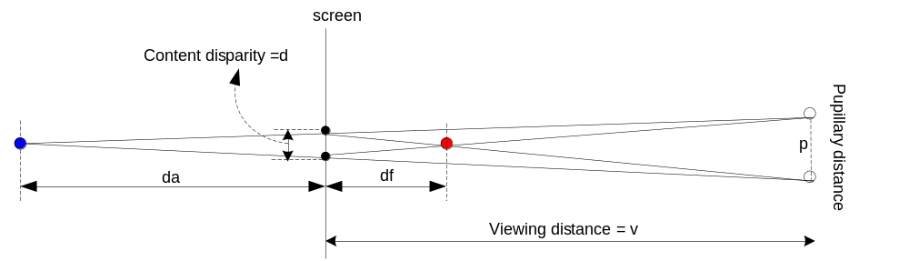
Fig.XX, Relationship between pupillary distance p, viewing distance v, content disparity d and depth range (d_{f}, d_{a})
Interpupillary distance: usually set as 6.5cm

Content disparity: it can be positive or negative. The original content disparity is described by the unit of pixels. However, due to the differences on the displaying screen size, the real distance of the disparity will be changed when using the unit of centi-meters. Positive values mean the eyes will be converged behind the screen (uncrossed disparity). Negative values mean the eyes will be converged in front of the screen (crossed disparity).
Depth range: the distance of the converged point (virtual object) in front of the screen and behind the screen.
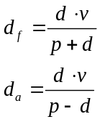

Even though displaying the same 3D content, as described above, screen size will change the depth range that observers perceive. The following figure shows three different screens with the size of 24”, 40”, and 46”. The viewing distance is 3H for all cases. The pupillary distance is set as 6.5cm. The 3D content disparity is +/- 30 pixels.
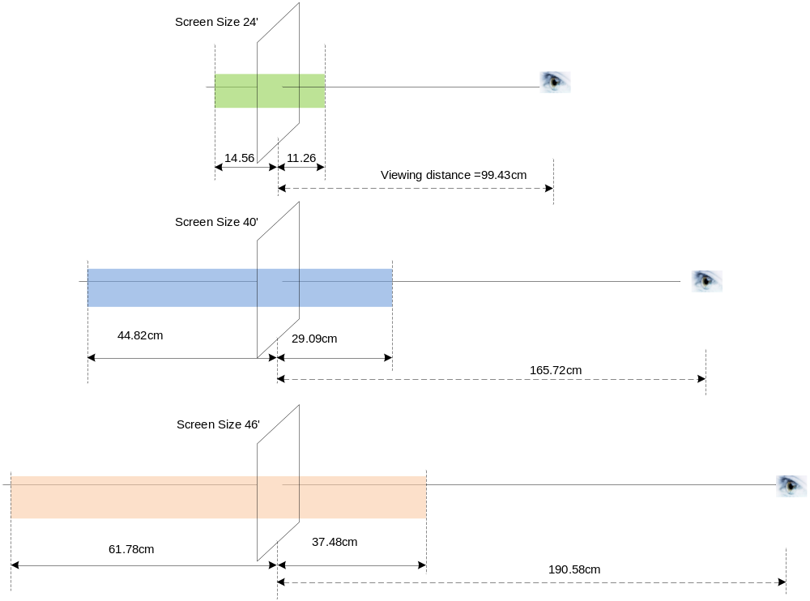

The following safety guidelines are recommended for filming, production, and selection of stereoscopic 3D video content.
- Fast spatial and temporal changes of disparity in stereoscopic 3D content should be avoided. The fast change of binocular disparity may induce visual discomfort accompanied by symptoms such as focusing difficulty and eye strain.
- To prevent visual discomfort, excessive disparity of stereoscopic 3D content should be avoided. Excessive binocular disparity may induce visual discomfort accompanied by symptoms such as focusing difficulty and eye strain.
- Image content with rotating or lateral shaking may induce the sensation of self-motion (visually induced self-motion sensation).
8.3 View asymetries
[Editor’s note: this section needs information about calibration errors between views. Reference table 1 of 3D-sam. This table lists the visibility thresholds. Research is required to determine discomfort thresholds, but the technical factors are identical.]
- Viewers may not feel comfortable viewing left and right images that have size, verticality, inclination, and brightness differences. Cross-talk between the left and right images may also have an impact on viewing comfort.
These safety guidelines may be ignored for brief periods of time, for creative purposes.
Thresholds for disparity should be expressed in angular degrees of the viewing angle.
[Editor’s note: read the following paragraph. See what if anything should be moved to clause 6.1 on accommodation-vergence; delete the rest.]
All 3DTV systems displayed on a screen in a single plane (such as a television screen) have limitations for a number of reasons. One of them is the potential conflict between convergence (the object that they eyes point themselves towards) and accommodation (the point on which the lens of the eye focuses) which the two signals gives rise to. The human eye focuses on an object according to the distance to that object. At the same time, we also control the convergence point (gaze point) on the object. Therefore, there is no inconsistency between accommodation and convergence in our everyday life. However when viewing 3D images, the focus point (accommodation) must always be fixed on the screen, independent of the convergence point which is derived from the disparity of the signals. Otherwise, the observer cannot focus clearly. Thus, an inconsistency between accommodation and convergence is introduced in 3D systems Optimizing 3D systems is the process of minimizing the effects of the limitations.
Visual fatigue caused by viewing stereoscopic motion images is a particular safety concern. Viewers’ repeated adaptation to the discrepancy between eye convergence and accommodation causes a decline of their visual functions and results in visual fatigue.
8.4 Scene cuts

Attention should be paid to the distribution of parallaxes in the stereoscopic images. From the correlations between psychological factors and the parallax distribution, we can grasp the essential characteristics of stereoscopic images, e.g., the sense of presence they convey and their ease of viewing. The parallax distribution of stereoscopic images is discontinuous during scene-change frames, where the scene depth and perceived convergence distance change. We need to evaluate how these changes affect the visual discomfort experienced during viewing of stereoscopic images.
8.5 Excessive disparity/parallax

Excessive disparity/parallax would cause visual discomfort. A possible reason is that if the disparity is large enough, the conflict between accommodation and vergence will be increasing. In addition, the observer may feel annoyance due to the difficulties in fusing the left and right eye images. This occurs as a consequence of the fusion limit, which will introduce "double vision".
Therefore, it has been suggested that, to minimize the accommodation-vergence conflict and to avoid "double vision", the disparities in the stereoscopic images should be small enough so that the perceived depths of objects can fall within the “comfortable viewing zone” defined in clause 6.3.
Excessive 3D Pop-out effects in content shall be limited in number of times occurances and duration.

9 3D Viewer Guidelines
9.1 The Influence of Stereopsis and Abnormal Binocular Vision (ABV)
Subjects with abnormal binocular vision such as strabismus, amblyopia, and anisometropia have decreased 3D perception (e.g., more difficulty perceiving 3D).
Among people with ABV, subjects that have a normal degree of stereopsis are more sucsceptible to 3D fatigue than subjects that have poor stereopsis. This includes 3D fatigue symptoms such as dizziness, headaches, eye fatigue, and pain. A normal degree of stereopsis is for example good stereopsis as measured with a Titmus stereofly test.
If a person cannot perceive 3D, or feels severe 3D fatigue while watching 3D content, he or she should consult ophthalmologic specialists for evaluation of abnormal binocular vision. However, badly produced 3D content will cause 3D fatigue in everyone.
Visual functions vary greatly from person to person, so it is essential to understand that there are individual differences before subjective assessment begins. For instance, there are limits to the binocular parallax of left and right images which a person can fuse into one image; when the parallax exceeds these limits, a double image is perceived. In this situation, depth perception collapses and viewing becomes extremely uncomfortable. For this reason, it is necessary to know the range of binocular parallax over which two images can be fused into one. However, individual differences are vast and will necessitate a study of the stereopsis function of many people.

9.2 Warnings for Subjects
Viewers of 3DTV should be made aware of the following warnings:
- Avoid viewing 3D TV if body functions start to deteriorate or if excessive stress is perceived.
- Stop viewing 3D TV if double vision is experienced.
- Image content with rotating or lateral shaking may induce the sensation of self-motion (visually induced self-motion sensation). Stop watching 3D TV temporarily if you feel uncomfortable with this sensation.
- Individuals with a shorter interpupilary distance may feel more visual discomfort with 3D TV than others (e.g., children).
- Individuals who experience motion sickness in automobiles or amusement park rides may experience more visual discomfort during 3D TV viewing.

9.3 Symptoms of 3D visual fatigue

The following symptoms may indicate 3D visual fatigue. More information can be found in [b-Kuze].
- Difficulty in tracking the motion on TV
- Eye strain: blurred vision, bleary, dry eyed, gritty, eye ache, sting, eyes heavy, hazy, warm eyes, flickering and watery eyes.
- Focusing difficulty: double vision, near vision difficulty, far vision difficulty, and trouble fusing stereoscopic images.
- General fatigue symptoms: feeling heavy in the head, difficulty in concentration, dizziness, stiff shoulder and stiff neck.
- Headache: pain in the temple and pain in the middle of the forehead.
- Nausea: vomiting and vertigo.
- Transient visual dimness after watching TV
If a person feels any of these symptoms, it may be an indication of visual fatigue. He or she should stop 3D TV viewing until the side effect disappears.
If a person repeatedly experiences 3D fatigue symptoms, he or she should consult ophthalmologic specialists for evaluation of abnormal binocular vision. The 3D TV hardware operation should also be examined for problems.

10 3D Viewing Environment and Playback Guidelines

Illumination, sound, viewing height, and TV brightness and focus should be adjusted to comfortable levels when watching 3D TV.
If an image appears as a double image or if it is hard to perceive a 3D image, stop using the system and check for errors in the display settings. If you still experience stereopsis problems with no apparent hardware problems, then you should temporarily stop viewing 3D TV.
Some viewers might not notice whether left and right images are reversed. The reversed vision of left and right images can cause visual fatigue and discomfort. Reversed left and right images can be caused by many problems (e.g., editing errors, hardware problems, camera setup, viewing angle).
10.1 Relationship Between Viewer and 3D Monitor
The viewer should be seated as advised by the 3D television manual, at a comfortable distance from the monitor. For television monitors, a minimum of 3H (three times picture height) is advised. For computer monitors, a minimum of 1.5H is advised.
Optimal 3D viewing means the viewer should be seated upright, in front of the screen (i.e., minimal head tilt). The viewing direction should be normal (e.g., head facing perpendicular) to the screen. The horizontal viewing angle from the screen should be minimum (e.g., face the screen directly instead of at an angle).
Television
Viewer
α
α marks the viewing angle
The viewer has the preferred viewing direction and viewing angle: head facing perpendicular to the screen, and zero degree viewing angle.

Viewer
Television
Figure 1. Diagram demonstrates viewing direction and viewing angle. It is generally said that the minimum value for depth of field of the human eye is ±0.3 D, where diopter (D) is the reciprocal value of distance (m). This means that we can perceive the image without defocusing when the object is located within ±0.3 D. When viewing 3D television, the accommodation point is fixed on the screen, and therefore 3D pictures should preferably be displayed within this range. Since ordinary television programs include images at infinite distance, the desirable range of depth to be displayed with 3D systems is considered to be within 0 to 0.6 D. Therefore, 0.3 D, i.e. 3.3 m, is considered to be the optimum viewing distance.
Camera parameters (camera separation, camera convergence angle, focal length of lens), resolution of the system and the frame effect should be taken into account in determining viewing conditions (screen size). In the case of HDTV when watching at the standard viewing distance of 3 H (H denotes picture height), the viewing distance of 3.3 m corresponds to a 90-inch screen. In the case of standard definition television (SDTV) when watching at the standard viewing distance of 6 H, this distance corresponds to a 36 inch screen. A subjective assessment of the relationship between screen size and depth perception was carried out with 3D HDTV system, and the results showed that the most natural depth perception was obtained with a screen size of 120 inches, which corresponds to viewing distance of 2.2 H.
The effective viewing angle should allow 20% angular rotation of head movement in the horizontal plane.
10.2 Viewing Time and Visual Fatigue
Acceptable viewing time for 3D content varies depending upon the content. A short time resting is recommended for every 1 or 2 hours, or when the eyes feel tired.
11 Assessment methods for symptoms of visual fatigue
11.1 Questionnaire to assess symptoms of visual fatigue

Appendix II provides a questionnaire to assess the symptoms of visual fatigue. This questionnaire is taken from [b-Kennedy].
For an example of this technique, see [b- Brunnström].
11.2 Pair comparison (PC) subjective test to visual discomfort

In ITU-T P.913, the method of Pair Comparison has been well defined. In Pair Comparison, the test sequences are presented in pairs, consisting of the same sequence being presented first through one system under test and then through another system. In 3DTV condition, generally, we compare two sequences with the same content but different distortions, or disparity setting, etc.
The Pair Comparison method requires that for the test sequences, for example, N different HRCs, the observers have to compare all the possible pairs, which leads to N(N–1) pairs for one content (if considering the influence of presentation order) or N(N–1)/2 pairs (if without considering the presentation order).
To avoid the influence of presentation order, all the pairs of sequences must be displayed in both the possible orders (e.g. AB, BA). This can be implemented by one observer (the observer watches AB and BA) or by a group of observers, which means, for one observer, if he watches pair AB, there must be another observer who watches the pair with the order BA.
After each pair a judgement is made on which element in a pair is preferred in the context of the test scenario. For the assessment of visual discomfort or visual fatigue, the question to observer may be "which one is more comfortable/uncomfortable?".
In Paired Comparison tests, there are two presentation patterns for the stimulus pair, i.e., the way to display the stimulus pair to observers. The stimuli can either be presented one after the other on a single screen ("Time-sequential presentation") or they can be presented on two well calibrated and synchronized screens ("Time-parallel presentation"). Different presentation patterns can be used for different experimental setups.
The time pattern for the stimulus presentation can be illustrated by Figure X.a and Figure X.b. The voting time should be less than or equal to 10 s, depending upon the voting mechanism used. The presentation time should be about 10 s and it may be reduced or increased according to the content of the test material.
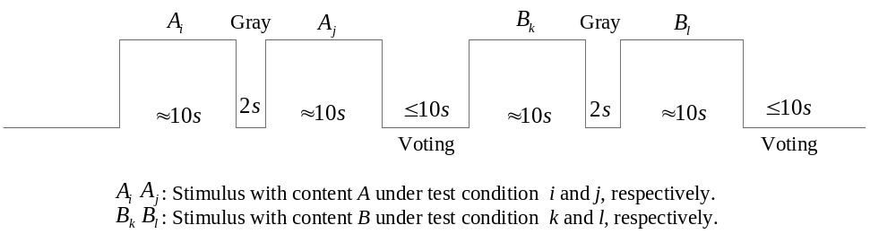
Figure X.a Time pattern for time-sequential pair comparison presentation

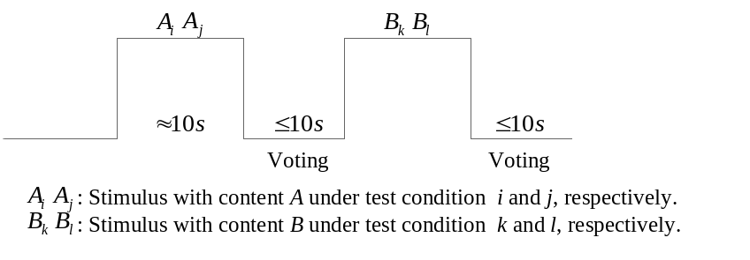
Figure X.b Time pattern for time-parallel pair comparison presentation

Appendix I
Open Questions
(This appendix does not form an integral part of this Recommendation)
More research is needed on the accommodation-vergence conflict. [b-Shiomi] indicates that there is no accommodation-vergence conflict.
More research is needed on the relationship between viewing distance and monitor type (e.g., active vs passive).
Appendix II
Visual Fatigue Questionnaire
(This appendix does not form an integral part of this Recommendation)
This appendix provides an example questionnaire. The questions may be adapted as to the requirements of the specific experiment.
The following questionnaire on visual fatigue is conducted in two phases. The first set of questions is answered by observers prior to the subjective assessment in order to draw their attention to certain effects:
- Are you blinking your eyes more frequently than usual today? (No, slightly, a bit, to a larger extent, much more frequently than usual)
- Do you have difficulties with your near vision today (Reading, cooking, sewing)? (No, slightly, a bit, to a larger extent, much more)
- Do you have difficulties with night vision? (No, slightly, a bit, to a larger extent, a lot)
- Do you have double vision? (No, slightly, a bit, to a larger extent, a lot)
- Do you feel pain at the back of your head? (No, slightly, a bit, to a larger extent, a lot)
- Do you have problems focusing? (No, slightly, a bit, to a larger extent, a lot)
- Do you have difficulties driving at night? (No, slightly, a bit, to a larger extent, a lot)
- Are you worried about your vision? (Never, Rarely, Sometimes, Often, Always)
- Are your eyes watering? (No, slightly, a bit, to a larger extent, a lot)
- At this moment, your two-eyed vision is: (Excellent, very good, good, fair, poor)
- Do you have dry eyes? (No, slightly, a bit, to a larger extent, a lot)
- Do you have a stiff neck? (No, slightly, a bit, to a larger extent, a lot)
After the subjective experiment, the following questions are answered:
- Do you have the sensation that the movement of your eyes is decoupled? (yes, no)
- With respect to the beginning of the experiment, do you experience (a lot more, slightly more, a little bit more, the same, a little bit less, slightly less, a lot less) stiffness of your neck?
- With respect to the beginning of the experiment, do you experience (a lot more, slightly more, a little bit more, the same, a little bit less, slightly less, a lot less) stiffness of your neck?
- With respect to the beginning of the experiment, do you experience (a lot more, slightly more, a little bit more, the same, a little bit less, slightly less, a lot less) eye strain?
- With respect to the beginning of the experiment, do you experience (a lot more, slightly more, a little bit more, the same, a little bit less, slightly less, a lot less) dizziness?
- With respect to the beginning of the experiment, do you experience (a lot more, slightly more, a little bit more, the same, a little bit less, slightly less, a lot less) lightheaded?
- With respect to the beginning of the experiment, do you experience (a lot more, slightly more, a little bit more, the same, a little bit less, slightly less, a lot less) heavy eye lids?
- Did your eyes water during the experiment? (yes/no)
- With respect to the beginning of the experiment, do you experience (a lot more, slightly more, a little bit more, the same, a little bit less, slightly less, a lot less) stiffness of your neck?
- With respect to the beginning of the experiment, do you experience (a lot more, slightly more, a little bit more, the same, a little bit less, slightly less, a lot less) stabbing pain in your eyes?
- With respect to the beginning of the experiment, do you experience (a lot more, slightly more, a little bit more, the same, a little bit less, slightly less, a lot less) pain at the front of your head?
- With respect to the beginning of the experiment, do you experience (a lot more, slightly more, a little bit more, the same, a little bit less, slightly less, a lot less) fatigue in the eyes?
- With respect to the beginning of the experiment, do you experience (a lot more, slightly more, a little bit more, the same, a little bit less, slightly less, a lot less) problems concentraing?
- With respect to the beginning of the experiment, do you experience (a lot more, slightly more, a little bit more, the same, a little bit less, slightly less, a lot less) sleepiness?
- With respect to the beginning of the experiment, do you experience (a lot more, slightly more, a little bit more, the same, a little bit less, slightly less, a lot less) pain at your temples?
- With respect to the beginning of the experiment, do you experience (a lot more, slightly more, a little bit more, the same, a little bit less, slightly less, a lot less) nausea?
- With respect to the beginning of the experiment, do you experience (a lot more, slightly more, a little bit more, the same, a little bit less, slightly less, a lot less) blurred vision?
- Do you have the feeling that your eyes are looking in different directions (yes/no)
- With respect to the beginning of the experiment, do you experience (a lot more, slightly more, a little bit more, the same, a little bit less, slightly less, a lot less) eye blinking?
- During the experiment, did you close your eyes in order to reestablish a clear vision (yes/no)
- Do you experience double vision (yes/no)?
- With respect to the beginning of the experiment, do you experience (a lot more, slightly more, a little bit more, the same, a little bit less, slightly less, a lot less) pain at the back of your head?
- With respect to the beginning of the experiment, do you experience (a lot more, slightly more, a little bit more, the same, a little bit less, slightly less, a lot less) difficulties focusing?
- With respect to the beginning of the experiment, do you experience (a lot more, slightly more, a little bit more, the same, a little bit less, slightly less, a lot less) watering of the eyes?
- With respect to the beginning of the experiment, do you experience (a lot more, slightly more, a little bit more, the same, a little bit less, slightly less, a lot less) dry eyes?
- With respect to the beginning of the experiment, do you experience (a lot more, slightly more, a little bit more, the same, a little bit less, slightly less, a lot less) pain in your shoulders?
- During the experiment, did you need to look at a different object than the screen? Which one? (Yes – object, No)

Bibliography
[b- Brunnström] Brunnström, K., Wang, K., and Andrén, B., "Simulator sickness analysis of 3D video viewing on passive 3DTV", Stereoscopic Displays and Applications XXIV, Vol: 8648, A. J. Woods, N. S. Holliman, and G. E. Favolora Eds., paper 1 (2013)
[b-Chen] Chen, W.; Fournier, J.; Barkowsky, M. & Callet, P. L. (2010), “New Requirements of Subjective video quality assessment methodologies for 3DTV,” Video Processing and Quality Metrics 2010 (VPQM), Scottsdale, USA.
[b-Chen2] Chen, W.; Fournier, J.; Barkowsky, M. & Callet, P. L. (2011), 'New stereoscopic video shooting rule based on stereoscopic distortion parameters and comfortable viewing zone', Stereoscopic Displays and Applications XXII. Proceedings of the SPIE 7863, 78631O-78631O-13.
[b-Cormack] Robert Cormack, “The computation of retinal disparity,” Perception and Psychophysics, vol. 37, no. 2, pp. 176–178, 1985
[b-Kennedy] Kennedy, R. S., Lane, N. E., Berbaum, K. S., and Lilienthal, M. G., "Simulator Sickness Questionnaire: An Enhanced Method of Quantifying Simulator Sickness", The International Journal of Aviation Psychology 3 (3), 203-220 (1993)
[b-Mendiburu] MENDIBURU B., 3D movie making : stereoscopic digital cinema from script to screen, Focal Press, Burlington, MA, Etats-Unis, 2009

[b-Kuze] Kuze, J., & Ukai, K. (2008). “Subjective evaluation of visual fatigue caused by motion images,” Displays, 29(2), 159–166.
[b-Lin] T.-H. Lin and S.-J. Hu, “Perceived depth analysis for view navigation of stereoscopic three-dimensional models,” Journal of Electronic Imaging, vol. 23, no. 4, p. 043014, 2014
[b-Schreiberetal] Schreiberetal, K.M.,“Thesurfaceoftheempiricalhoropter,”Journal of Vision 8(3), 1–20 (2008).
[b-Shiomi] Shiomi, T., Hori, H., Uemoto, K., Miyao, M., Takada, H., Hasegawa, S., Omori, M., Watanabe, T., and Ishio, H., "Comparison of Simultaneous Measurement of Lens Accommodation and Convergence in Natural Vision and 3D Vision", SID Symposium Digest of Technical Papers, Vol: 43, 1178-1181 (2012)
[b-Speranza] SPERANZA F., TAM W. J., RENAUD R., HUR N., « Effect of disparity and motion on visual comfort of stereoscopic images », Proceedings of SPIE Stereoscopic Displays and Virtual Reality Systems XIII, vol. 6055, San Jose, CA, Etats-Unis, p. 94–103, 2006

[b-Tam] W.J. Tam, F. Speranza, S. Yano, K. Shimono, and H. Ono. Stereoscopic
3D-TV: visual comfort. Broadcasting, IEEE Transactions on, 57(2):335–346,
2011.

[b-Woods] Andrew Woods, Tom Docherty, and Rolf Koch, “Image distortions in stereoscopic video systems,” Proceedings of the SPIE, Stereoscopic Displays and Applications IV, 1993, vol. 1915, pp. 36–48.
[b-Yano] YANO S., IDE S., MITSUHASHI T., THWAITES H., « A study of visual fatigue and visual comfort for 3D HDTV/HDTV images », Displays, vol. 23, n˚4, p. 191–201, 2002.

______________________

