Hybrid Project – Boulder 2014 – session 2

Objective results:

Do proponents agree to put their names and model type on the model performance analysis?
Do proponents agree to exchange the objective data among the other proponents?
All proponents agreed.

Issues with PVSs:

VGA3

Tandem coding: Encode at bitrate b_1, the re-encode at bitrate b_2, with b_2 > b_1
v03_src12_hrc15_h264.pcap (2.36MB/885kB = 2.73)
Content-Base: rtsp://192.168.169.77/Tandem_coding2_512kbits_1380kbits/HybridVGA3_src12_512_1380kbit_gop50_baseline_tandem.264/
Open: v03_src12_hrc15.
Agreed to remove v03_src12_hrc15.

WVGA2:
Down-up-sampling PVSs: MOS has to be equal or larger to the MOS of the samples transmitted without resizing.
Down-Up-sampling | HRC11 | HRC04 | Same resolution
HybridWGA2_src01_hrc11_WVGA_25fps.avi | 1.52 | 2.96 | HybridWGA2_src01_hrc04_WVGA_25fps.avi
HybridWGA2_src02_hrc11_WVGA_25fps.avi | 1.57 | 1.30 | HybridWGA2_src02_hrc04_WVGA_25fps.avi
HybridWGA2_src03_hrc11_WVGA_25fps.avi | 1.39 | 1.57 | HybridWGA2_src03_hrc04_WVGA_25fps.avi
HybridWGA2_src04_hrc11_WVGA_25fps.avi | 1.61 | 1.04 | HybridWGA2_src04_hrc04_WVGA_25fps.avi
HybridWGA2_src05_hrc11_WVGA_25fps.avi | 1.57 | 1.48 | HybridWGA2_src05_hrc04_WVGA_25fps.avi
HybridWGA2_src06_hrc11_WVGA_25fps.avi | 1.39 | 1.91 | HybridWGA2_src06_hrc04_WVGA_25fps.avi
HybridWGA2_src07_hrc11_WVGA_25fps.avi | 1.35 | 1.09 | HybridWGA2_src07_hrc04_WVGA_25fps.avi
HybridWGA2_src08_hrc11_WVGA_25fps.avi | 1.57 | 2.09 | HybridWGA2_src08_hrc04_WVGA_25fps.avi
Average | 1.49 | 1.68
HybridVGA3_csrc02_hrc11_WVGA_25fps_dec.avi | 2.35
HybridVGA3_csrc04_hrc11_WVGA_25fps_dec.avi | 2.52
 | HRC09 | HRC03
HybridWVGA1_csrc01_hrc09_WVGA_25fps_dec.avi | 1.22
HybridVGA2_csrc03_hrc09_WVGA_25fps_dec.avi | 1.09 | 1.65 | HybridWVGA2_csrc03_hrc03_WVGA_25fps_dec.avi
HybridWGA2_src01_hrc09_WVGA_25fps.avi | 3.87 | 3.09 | HybridWGA2_src01_hrc03_WVGA_25fps.avi
HybridWGA2_src02_hrc09_WVGA_25fps.avi | 3.43 | 2.48 | HybridWGA2_src02_hrc03_WVGA_25fps.avi
HybridWGA2_src03_hrc09_WVGA_25fps.avi | 3.00 | 2.52 | HybridWGA2_src03_hrc03_WVGA_25fps.avi
HybridWGA2_src04_hrc09_WVGA_25fps.avi | 3.52 | 1.78 | HybridWGA2_src04_hrc03_WVGA_25fps.avi
HybridWGA2_src05_hrc09_WVGA_25fps.avi | 2.74 | 2.00 | HybridWGA2_src05_hrc03_WVGA_25fps.avi
HybridWGA2_src06_hrc09_WVGA_25fps.avi | 3.43 | 2.35 | HybridWGA2_src06_hrc03_WVGA_25fps.avi
HybridWGA2_src07_hrc09_WVGA_25fps.avi | 3.22 | 2.00 | HybridWGA2_src07_hrc03_WVGA_25fps.avi
HybridWGA2_src08_hrc09_WVGA_25fps.avi | 3.78 | 3.17 | HybridWGA2_src08_hrc03_WVGA_25fps.avi

Agreed to keep HRC11.

Review of Subjective Results

Expert ratings for some data sets:
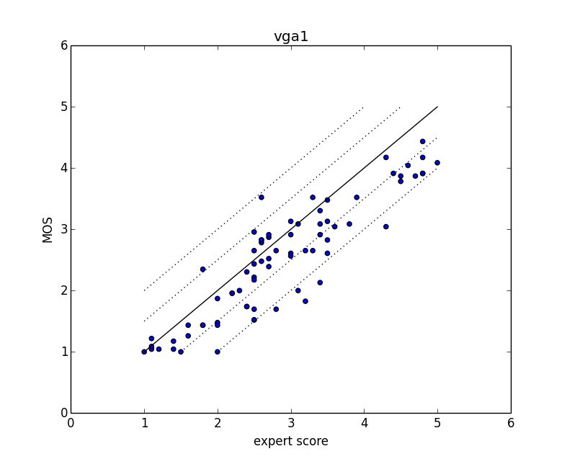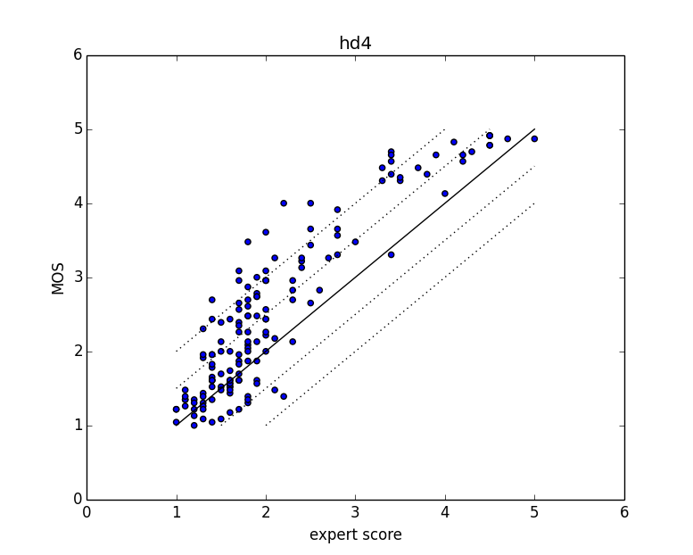
Comments:
VGA1: the MOS scores are in general lower than the expert scores. This might partly explain the low MOS on the reference sequences.
HD4: the plot shows a strong non-linear relationship between expert scores and MOS scores.

Source scores:
Some sources have a MOS below 4 (see plots MOS of sources, analyse_subjective_score_source.py).
hd1_src02.avi
hd2_src03.avi
hd2_src05.avi
hd2_src08.avi
vga1_src03.avi
vga1_src09.avi
vga1_src10.avi
vga3_src05.avi
ILG will review these source videos and make a decision.

Common Set Mapping

Common set ratings, difference per experiment
(See plots analyse_subjective_score_common.py)
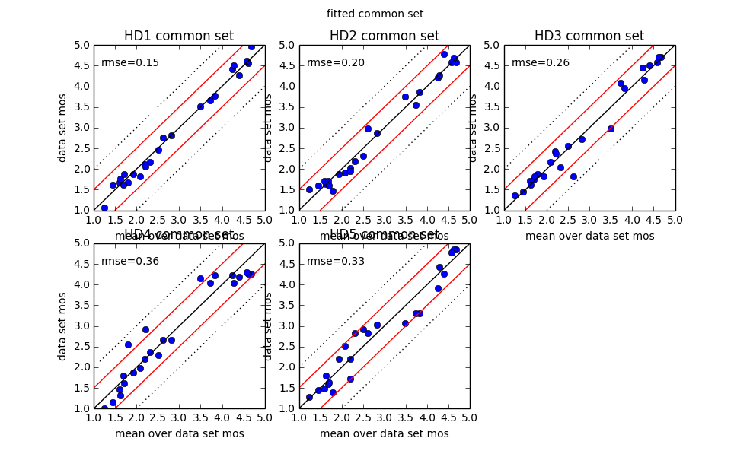
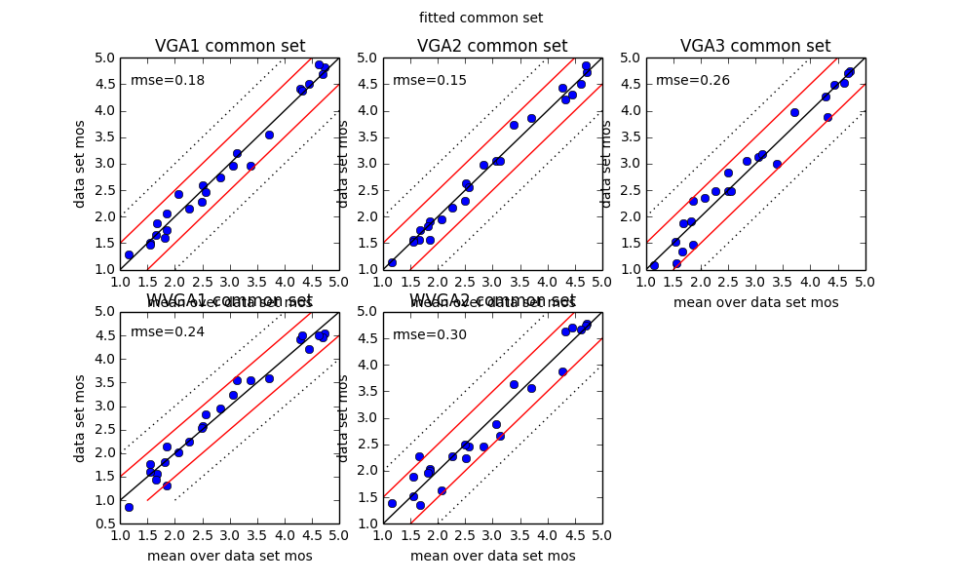
Accepted: Move superset analysis to secondary analysis.

