Hybrid Project – Boulder 2014

Issues with PVSs:

HD2:

HRC13, HRC15 use High-4:2:2 profile. AGREED to remove these PVSs.

Files h02_src02_hrc01.pcap, h02_src07_hrc01.pcap have packet loss, but the HRC is coding degradation only. . AGREED to remove these PVSs.

VGA3

Tandem coding: Encode at bitrate b_1, the re-encode at bitrate b_2, with b_2 > b_1

8 PVSs outside of limit in test plan:
v03_src01_hrc15_h264.pcap (799/349 = 2.29)
Content-Base: rtsp://192.168.169.77/Tandem_coding2_192kbits_490kbits/HybridVGA3_src01_192_490kbit_gop50_tandem.264/
v03_src04_hrc15_h264.pcap (1.040MB/438 = 2.43)
Content-Base: rtsp://192.168.169.77/Tandem_coding2_240kbits_612kbits/HybridVGA3_src04_240_612kbit_gop50_baseline_tandem.264/
v03_src06_hrc15_h264.pcap (0.970MB/411 = 2.42)
Content-Base: rtsp://192.168.169.77/Tandem_coding2_240kbits_612kbits/HybridVGA3_src06_240_612kbit_gop50_baseline_tandem.264/
v03_src07_hrc15_h264.pcap(965/374 = 2.58)
Content-Base: rtsp://192.168.169.77/Tandem_coding2_240kbits_612kbits/HybridVGA3_src07_240_612kbit_gop50_baseline_tandem.264/
v03_src08_hrc15_h264.pcap(2.270MB/870=2.67)
Content-Base: rtsp://192.168.169.77/Tandem_coding2_512kbits_1380kbits/HybridVGA3_src08_512_1380kbit_gop50_baseline_tandem.264/
v03_src11_hrc15_h264.pcap (2.27MB/883=2.63)
Content-Base: rtsp://192.168.169.77/Tandem_coding2_512kbits_1380kbits/HybridVGA3_src11_512_1380kbit_gop50_baseline_tandem.264/
v03_src12_hrc15_h264.pcap ()
Content-Base: rtsp://192.168.169.77/Tandem_coding2_512kbits_1380kbits/HybridVGA3_src12_512_1380kbit_gop50_baseline_tandem.264/
v03_src14_hrc15_h264.pcap (1.03MB/432=2.44)
Content-Base: rtsp://192.168.169.77/Tandem_coding2_240kbits_612kbits/HybridVGA3_src14_240_612kbit_gop50_baseline_tandem.264/
Accepted to exclude:
v03_src07_hrc15, v03_src08_hrc15, v03_src11_hrc15
Open: v03_src12_hrc15
Other samples from hrc15 will remain included in VGA3.

WVGA2:
Down-up-sampling PVSs: MOS has to be equal or larger to the MOS of the samples transmitted without resizing.
Down-Up-sampling | HRC11 | HRC04 | Same resolution
HybridWGA2_src01_hrc11_WVGA_25fps.avi | 1.52 | 2.96 | HybridWGA2_src01_hrc04_WVGA_25fps.avi
HybridWGA2_src02_hrc11_WVGA_25fps.avi | 1.57 | 1.30 | HybridWGA2_src02_hrc04_WVGA_25fps.avi
HybridWGA2_src03_hrc11_WVGA_25fps.avi | 1.39 | 1.57 | HybridWGA2_src03_hrc04_WVGA_25fps.avi
HybridWGA2_src04_hrc11_WVGA_25fps.avi | 1.61 | 1.04 | HybridWGA2_src04_hrc04_WVGA_25fps.avi
HybridWGA2_src05_hrc11_WVGA_25fps.avi | 1.57 | 1.48 | HybridWGA2_src05_hrc04_WVGA_25fps.avi
HybridWGA2_src06_hrc11_WVGA_25fps.avi | 1.39 | 1.91 | HybridWGA2_src06_hrc04_WVGA_25fps.avi
HybridWGA2_src07_hrc11_WVGA_25fps.avi | 1.35 | 1.09 | HybridWGA2_src07_hrc04_WVGA_25fps.avi
HybridWGA2_src08_hrc11_WVGA_25fps.avi | 1.57 | 2.09 | HybridWGA2_src08_hrc04_WVGA_25fps.avi
average | 1.49 | 1.68
HybridVGA3_csrc02_hrc11_WVGA_25fps_dec.avi | 2.35
HybridVGA3_csrc04_hrc11_WVGA_25fps_dec.avi | 2.52
 | HRC09 | HRC03
HybridWVGA1_csrc01_hrc09_WVGA_25fps_dec.avi | 1.22
HybridVGA2_csrc03_hrc09_WVGA_25fps_dec.avi | 1.09 | 1.65 | HybridWVGA2_csrc03_hrc03_WVGA_25fps_dec.avi
HybridWGA2_src01_hrc09_WVGA_25fps.avi | 3.87 | 3.09 | HybridWGA2_src01_hrc03_WVGA_25fps.avi
HybridWGA2_src02_hrc09_WVGA_25fps.avi | 3.43 | 2.48 | HybridWGA2_src02_hrc03_WVGA_25fps.avi
HybridWGA2_src03_hrc09_WVGA_25fps.avi | 3.00 | 2.52 | HybridWGA2_src03_hrc03_WVGA_25fps.avi
HybridWGA2_src04_hrc09_WVGA_25fps.avi | 3.52 | 1.78 | HybridWGA2_src04_hrc03_WVGA_25fps.avi
HybridWGA2_src05_hrc09_WVGA_25fps.avi | 2.74 | 2.00 | HybridWGA2_src05_hrc03_WVGA_25fps.avi
HybridWGA2_src06_hrc09_WVGA_25fps.avi | 3.43 | 2.35 | HybridWGA2_src06_hrc03_WVGA_25fps.avi
HybridWGA2_src07_hrc09_WVGA_25fps.avi | 3.22 | 2.00 | HybridWGA2_src07_hrc03_WVGA_25fps.avi
HybridWGA2_src08_hrc09_WVGA_25fps.avi | 3.78 | 3.17 | HybridWGA2_src08_hrc03_WVGA_25fps.avi

Will be re-discussed tomorrow

Common set:
Timestamps must be set according to DTS and must be monotonically increasing, this does not hold for
HybridHD1_csrc03_HRC06_HD_30fps.pcap
HybridHD1_csrc03_HRC14_HD_30fps.pcap
HybridHD2_csrc03_HRC02_HD_30fps.pcap
Accepted: these 3 PVSs will be removed from objective data evaluation (but used for determining superset mapping).
Common set: HybridHD5_csrc01_hrc12_HD_25fps, HybridHD5_csrc01_hrc12_HD_30fps contain actually HybridHD2_csrc03_hrc09_HD_30fps.
Accepted to exclude this PVS from determining the superset mapping, but use it for objective evaluation.

Model crash
What if model does not return a value?
Proposition 1: Put a constant value.
Proposition 2: Eliminate that data point for that particular model.
Proposition 3: Eliminate that data point from all the model evaluations.
Proposition 4: Use the video only to make prediction (as stated in the test plan).
Proposition 5: If a model for the non-encrypted case crashes, use the predictions of the model for the encrypted case.
Accepted: Proponents decide between proposition 4 and 5.

Review of Subjective Results

Subject screening:
Some subjects have low correlation (see plots subject’s correlation, subjective_results.py)
WVGA1, subject number 13 should be excluded. Accepted

Source scores:
Some sources have a MOS below 4 (see plots MOS of sources, analyse_subjective_score_source.py).
hd1_src02.avi
hd2_src03.avi
hd2_src05.avi
hd2_src08.avi
vga1_src03.avi
vga1_src09.avi
vga1_src10.avi
vga3_src05.avi
ILG will review these source videos and make a decision.

Histogram of MOS per-experiment
HD1, HD4 have a strong non-uniform distribution (see plots histograms of MOS, subjective_results.py)
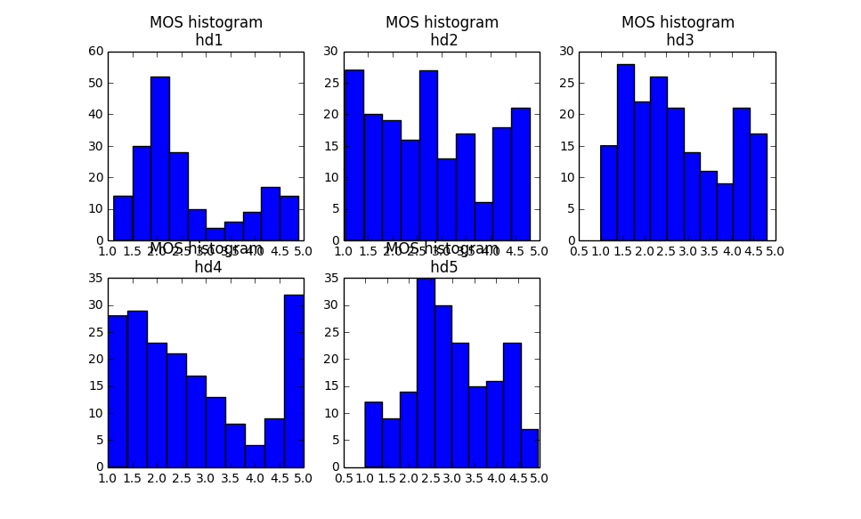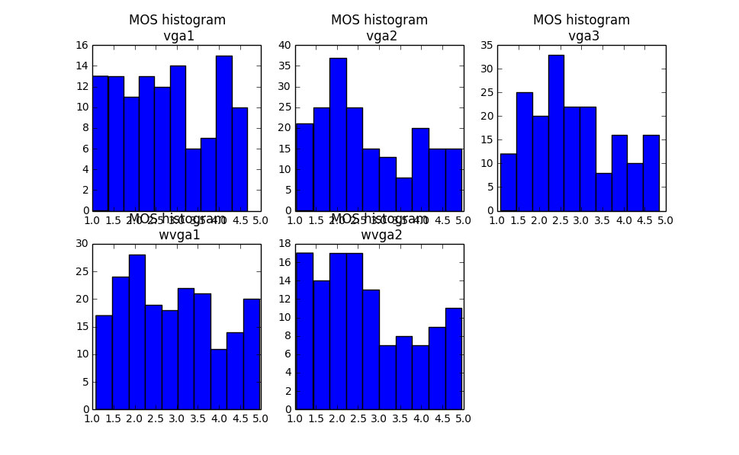

Model Performance Analysis
Decided at last meeting: Possibility to withdraw model from WVGA2 rebuffering.
Proposition: performance statistics for WVGA2 without rebuffering for all models and including rebuffering for those models which choose to. Accepted.

Common Set Mapping

Common set ratings, difference per experiment
(See plots analyse_subjective_score_common.py)
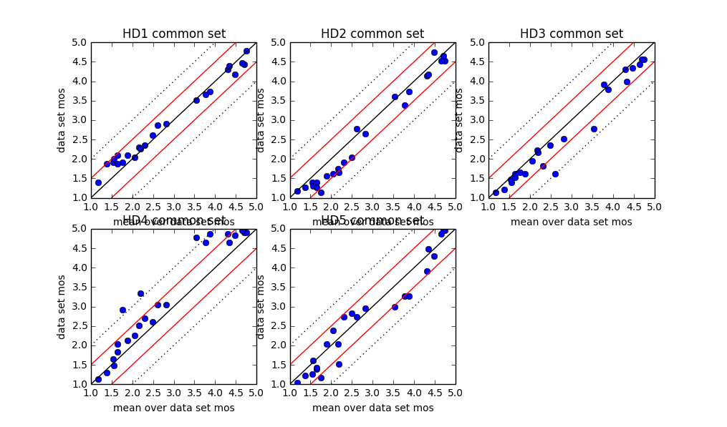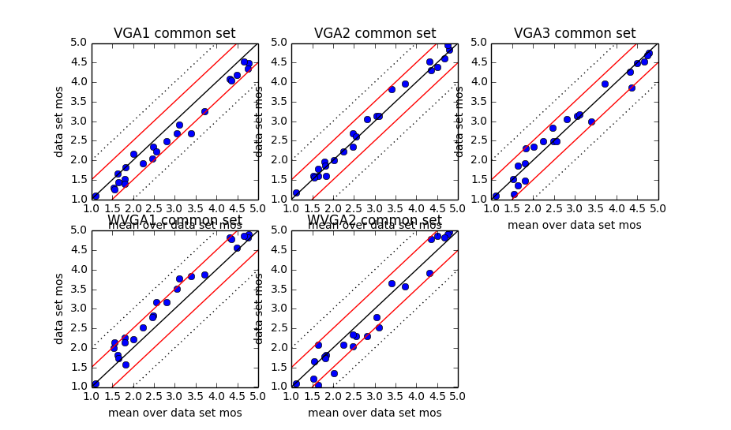
HD4: HD5 common set sequences get very high MOS compared to values in HD1, HD3, HD5
e.g. HybridHD5_csrc01_hrc12_HD_25fps

